**Cerner to RIS**

**ORM, ORR Requirements**

**Version 1.3**

**Prepared By: Art Schwartz & Tiffany Bohall**

**Date: 7/30/2019**

Document Control 3

Resources 3

Project Distribution List 3

Document Version Control 3

1. Introduction 4

1.1 Purpose 4

1.2 Project Scope 4

1.3 Terminology Standards 4

1.3.1 Acronyms 4

1.3.2 Glossary 4

1.4 Document References 4

*2.* Diagram 5

3. Requirements 5

3.1 Functional Requirements (Cerner FSI) 5

3.2 Non-Functional Requirements 6

3.3 Messaging Protocols 6

3.3.1 Inbound to the BayCare Cloverleaf 6

3.3.2 Outbound to the BayCare Cloverleaf 6

3.3.3 Inbound From 16057 the Vendor 6

3.3.4 Outbound to the Vendor 6

3.3.5 Inbound to the BayCare Cloverleaf 7

3.3.6 Outbound to RIS 7

4. HL7 Messaging 8

4.1 Messaging Format 8

4.1.1 Segments 8

4.1*.*2 Messaging Event Types 9

4.1*.*3 Cloverleaf Configuration Files 9

4.1.4 Cloverleaf Site Location 9

4.2 Data Transformation Requirements 9

4.3 Sample Messages 12

5. Testing 13

5.1. Unit Testing Scenarios 13

5.2 Integrated Testing Scenarios 13

5.3 Testing Approvals 14

5.4 Piloting 14

5.5 Approvals 14

6. Deployment / Implementation Model 14

Appendix A: Risks and Concerns 14

Appendix B: Issues List 15

Appendix C: Modifier Logic 15

# **Document Control**

## Resources

|  |  |  |
| --- | --- | --- |
| **Name** | **Role** | **Email** |
| Art Schwartz | BayCare Integration Analyst | Art.Schwartz@baycare.org |
| Sandi Lees | SYSTEMS ANALYST SR | [Sandy.Lees@baycare.org](mailto:Sandy.Lees@baycare.org) |
|  |  |  |
|  |  |  |
|  |  |  |
|  |  |  |
|  |  |  |
|  |  |  |

## Project Distribution List

## Document Version Control

|  |  |  |  |
| --- | --- | --- | --- |
| **Version** | **Date** | **Modifier** | **Description** |
| V1.0 | 5/11/2016 | Art Schwartz | Originally Created |
| V1.1 | 10/5/2016 | Tiffany Bohall | Modified interface for MCH pet scans |
| V1.2 | 6/13/2019 | Art Schwartz | Modified interface for Cerner Model |
| V1.3 | 7/30/19 | Charles Markwardt | Modified interface for Cerner Model |
|  |  |  |  |

# 1. Introduction

## 1.1 Purpose

This document outlines the Cerner to RIS ORM, ORR interface all functional requirements needed to support this solution post implementation will be included.

## 1.2 Project Scope

Implement an ORM, ORR interface from the GE Centricity Business Practice Management System to the BayCare employer portal for workman’s comp accounts

## 1.3 Terminology Standards

### 1.3.1 Acronyms

MLLP – Minimum Lower Layer Protocol for messaging framing a HL7 message.

CPI – Corporate Patient Identifier

Soarian EMPI = Enterprise Master Patient Index = CPI

### 1.3.2 Glossary

List the terms that require definition

## 1.4 Document References

# *2.* Diagram

ADT diagram

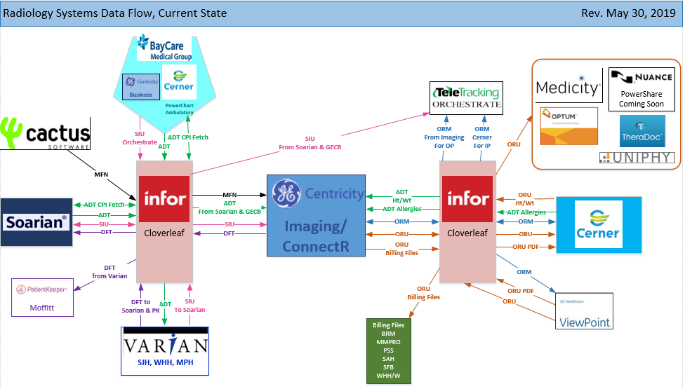

# 3. Requirements

## 3.1 Functional Requirements (Cerner FSI)

Provide detail for the below functional requirements. The message transformation requirements for the components defined in this specification should be specified in section 4.2 of this document.

|  |  |  |
| --- | --- | --- |
| **Number** | **Requirement Name** | **Requirement Description** |
| FR.2019.5.14 | Order selection logic | This script will suppress Radiology,MRiradiology message if the action type is one of the following action types ("STATUSCHANGE","MODIFY","COMPLETE") and the contributor system = “IDX” |
|  | Contributor system Invision | Invision is Cerner’s main contributor system. This system is used across multiple interface throught the orginzation. So when alais are added to the contributor source it will impact more than just this interface.  **Contributor Source:** Invision  **Organization:** Baycare Heatlh Systems  **Message Format:** HL7 V2.x  **Outbound Field Processing**  MSH.3 Sending Application = HNAM  MSH.4 Sending Facility = CERNER  MSH.5 Receiving Application = INVISION  MSH.6 Receiving Facility = BAYCARE  **Outbound aliasing**  OBX.3 Observation ID comes from the contributor source LOI  Continue only If PID-18.3 contains BayCare FIN  Kill if ORC-1 contains SC or F  Kill if OBR-4 contains any of the following; EKG EKGPEDINEO EKGRS EKGCONTSVT EKGPOST EKGRTSIDEDEKG15LEAD EKGSA  Disgard the following segments: IN1 IN2 IN3 ZEI ZN2 ZN3 |

FR.2019.08.15

## 

## 3.2 Non-Functional Requirements

Provide concise detail for the below non-functional requirements. The below requirements must be evaluated for every project.

|  |  |  |
| --- | --- | --- |
|  |  |  |
|  |  |  |
|  |  |  |
|  |  |  |
|  |  |  |

## 3.3 Messaging Protocols

Below are listed the details for the messaging protocols that will be leveraged for this integration. Please see the reference document located on the Integration SharePoint server: <insert link to document here>

### 3.3.1 Inbound to the BayCare Cloverleaf

* Click here to enter text.

### 3.3.2 Outbound to the BayCare Cloverleaf

* N/A

### 3.3.3 Inbound From 16057 the Vendor

Click here to enter text.

### 3.3.4 Outbound to the Vendor

* Click here to enter text.

### 3.3.5 Inbound to the BayCare Cloverleaf

**C30**

Port Number: 13194

IP Address: Cloverleaf IP 10.5.250.203, site **idx_12** & thread **orm_cer_in_crt**

ComServer: ORM_RADIOLOGY_OUT

**M30**

Port Number: 8154

IP Address: Cloverleaf IP 10.5.250.203, site **idx_12** & thread **orm_cer_in_mck**

ComServer: ORM_RADIOLOGY_OUT

**B30**

Port Number: 14169

IP Address: Cloverleaf IP 10.5.250.203, site **idx_12** & thread **orm_cer_in_bld**

**P30**

Port Number: 15050

IP Address: Cloverleaf IP 10.5.250.201, site **idx_prod** & thread **ceridx_ord_in**

ComServer: ORM_RADIOLOGY_OUT

### 3.3.6 Outbound to RIS

Test

Port Number: 8500

IP Address: RIS IP 10.4.3.12, site **idx_12** & thread **orm_idx_out_mck** Port Number: Click here to enter text.

Prod

Port Number: 8500

IP Address: RIS IP 10.4.3.167, site **idx_12** & thread **idxcer_soarord_out** Port Number: 11100

# 4. HL7 Messaging

## 4.1 Messaging Format

### 4.1.1 Segments

The segments utilized for this interface are:

MSH

[{NTE}]

PID

[PD1]

[{NTE}]

PV1

[PV2]

[{

IN1

[IN2]

[IN3]

[GT1]

[{AL1}}

ORC

OBR

[{NTE}]

[{DG1}]

[OBX]

[{NTE}]

}]

*Message Construction Notes:*

*[Square Brackets] – Optional*

*{Curly Brackets} – Repeatable*

*MSH – Message Header*

*EVN – Event segment*

*NTE – Patient ID segment*

*PV1 – Patient Visit segment*

*ORC – Common Order segment*

*IN1 – Insurance segment*

*[{ – Start of optional, repeatable group*

*}] – End of optional, repeatable group*

### 4.1*.*2 Messaging Event Types

Below are the messages types necessary for this integration

|  |  |
| --- | --- |
| **Event Type** | **Description** |
| ORM^O01 | Order |
| ORR^O01 | Order update |
|  |  |
|  |  |
|  |  |

### 4.1*.*3 Cloverleaf Configuration Files

Xlate – cener_idxrad_orm_1

### 4.1.4 Cloverleaf Site Location

**P30**

SITE **imaging_12_p**

## 4.2.1 FSI Data Transformation Requirements

| **Field Description** | **HL7 Field Loc.** | | **Required Y/N** | | **Data Type** | | **Length** | | **Notes** | |
| --- | --- | --- | --- | --- | --- | --- | --- | --- | --- | --- |
| Message Segment Header | | MSH | | Y | | Varies | | Varies | | Pathcopy the entire segment. | |
| Sending Application | | MSH.3 | | Y | |  | |  | | HNAM | |
| Sending Facility | | MSH.4 | | Y | | HD | | 227 | | CERNER | |
| Receiving Application | | MSH.5 | |  | |  | |  | | INVISION | |
| Receiving Facility | | MSH.6 | | Y | |  | |  | | BAYCARE | |

## 4.2.2 Cloverleaf Data Transformation Requirements

| **Field Description** | **HL7 Field Loc.** | **Required Y/N** | **Data Type** | **Length** | **Notes** |
| --- | --- | --- | --- | --- | --- |
| Message Segment Header | MSH | Y | Varies | Varies | Pathcopy the entire segment. |
| Sending Facility | MSH.4 | Y | HD | 227 | Pass MSH-5 thru Table cerner_idx_soarf_facility copy @fac |
| Receiving Application | MSH.5 |  |  |  | Pass MSH-5 thru Table cerner_idx_soarf_facility to @fac, copy @fac |
| Message type | MSH-9 | Y |  |  | Convert ORM_R01 to ORR_O02 if ORC-1 = NA. and copy IX to Orc-5    Supress any other ORM_R01 if ORC-18 = Rebound |
| Patient ID (external ID) | PID-2 | Y |  |  | Copy CPI from PID-3 |
| Patient Identifier List | PID.3 | Y | CX | 250 | Copying PID-2, **suppress if Null**  **Copy @fac to PID-3.6** |
| Patient Name: last, first, suffix | PID.5.0  PID.5.1  PID.5.3 | Y |  |  | Copy |
| Date/time of Birth | PID.7 | Y |  |  | Copy |
| Sex | PID.8 | Y |  |  | Copy |
| Patient Account Number | PID.18 | Y |  |  | Copy |
| SS# | PID-19 | Y |  |  | Copy |
| Patent Class | PV1.2 | Y |  |  | Copy |
| Assigned Patient Location | PV1.3 | Y | PL | 80 | Concatenate 1st 3 subfields into 2nd into subfield.  If urgent Care hard code RADUC into 2nd into subfield.  If fac = BCMCH and OBR.24 = PT, hard code NUICM outbound. |
| Attending Doctor | PV1.7.0  PV1.7.1  PV1.7.2  PV1.7.3 | Y |  |  | Iterate thru field and Find Baycare Dr Number in 9th subfield and copy first 4 subfields |
| referring Doctor | PV1.8.0  PV1.8.1  PV1.8.2  PV1.8.3 | Y |  |  | Iterate thru field and Find Baycare Dr Number in 9th subfield and copy first 4 subfields |
| Consulting Doctor | PV1.9.0  PV1.9.1  PV1.9.2  PV1.9.3 | Y |  |  | Iterate thru field and Find Baycare Dr Number in 9th subfield and copy first 4 subfields |
| Admitting Doctor | PV1.17.0  PV1.17.1  PV1.17.2  PV1.7.3 | Y |  |  | Iterate thru field and Find correct facility in 9th subfield and copy first 4 subfields |
| Patient Type | PV1-18 |  |  |  | If PV1-18 =  JHOUTREACH change to SJH in MSH-5  WOOUTREACH change to SJH in MSH-5  MPOUTREACH change to MPH in MSH-5 |
| Servicing Facility | PV1.39 | R | IS |  | Field is populated either by Cerner default logic OR by Cloverleaf logic.  Cerner default logic is to populate this field with PV1-3.4(Facility).  Cloverleaf overrides Cerner default logic for some locations where they have crosswalk table cerner_idx_soarf_facility to populate this field based on the value received in MSH-5 from Cerner in the orm message. |
| Admit Date/Time | PV1.44 | N | DTM | 24 | Copy |
| ORC segment | ORC |  |  |  | Pathcopy Segment |
| Order Control | ORC.1 | Y |  |  | if ORC.1 = CA, copy “99899” to ORC-11.  if ORC.1 = NA, Null out ORC-2, ORC-3 |
| Placer Order Number namespace | ORC.2.2 |  |  |  | Null out |
| Filler Order Number namespace | ORC.3.2 |  |  |  | Null out |
|  | ORC-5 |  |  |  | If = 77  Copy CA to ORC-1  Copy 85 to ORC-5  If = 20  Copy IX to ORC-5 |
| Entered By | ORC-10 |  |  |  | Hardcode “HISUSER” |
| Ordering Provider | ORC-12 |  |  |  | Iterate thru field and Find Baycare Dr Number in 9th subfield and copy first 4 subfields |
| OBR segment | OBR |  |  |  | Pathcopy segment |
| Placer order number entity ID | OBR.2.0 |  |  |  | Null out OBR-2.2 |
| Filler order Number | OBR-3 |  |  |  | Null out OBR-3.2 |
| @modifer |  |  |  |  | Concat OBX-3.2 , OBX-5 to @modifier |
| Universal service identifier ID | OBR.4.0 |  |  |  | Copy field + @modifier |
| @subdept |  |  |  |  | Copy OBR-24 to @subdept |
| Ordering provider ID, last name, first name, middle initial | OBR.16.0  OBR.16.1  OBR.16.2  OBR.16.3 | Y |  |  | If OBR.16.0 does not = null, copy OBR.16.0, OBR.16.1, OBR.16.2 and OBR.16.3 outbound.  If null send “ERROR” in OBR-16 |
| Quantity timing priority | OBR.27.5 |  |  |  | Copy thru table cer_idx_stat_priorty to variable @stat_priorty. If Y copy Y to OBR-27, ZOI-4. Else null out OBR-27 |
| Reason for study text | OBR.31.1 |  |  |  | If any iteration of OBX.3.0 contains “Reason for Procedure” copy OBX.5.0 into OBR.31.1 outbound. |
| Observation Identifier | OBX-3 |  |  |  | Concat OBX-3, OBX-5 to @modifier |
| Observation Value | OBX-5 |  |  |  | Concat OBX-3, OBX-5 to @modifier |
| Universal identifier | OBR-4 |  |  |  | Concat OBR-4 @modifier to OBR-4 |
| Diagnostic serv Sect ID | OBR-24 |  |  |  | Copy to @subdept |
| Diagnostic serv Sect ID | OBR-24 |  |  |  | Copy 1st 6 chars to @Cardio |
| Universal identifier | OBR-4 |  |  |  | If SAH and PV1-2 = E m and  OBR-24=CT  Concat OBR-4,@modifier and ECT to OBR-4 |
| Universal identifier | OBR-4 |  |  |  | If SAH and PV1-2 = E and  OBR-24=DX  Concat OBR-4,@modifier and EDX to OBR-4 |
| Universal identifier | OBR-4 |  |  |  | If SAH and OBR-30 = PO and OBR-24 = DX  Concat PO to end of OBR-4 |
| Universal identifier | OBR-4 |  |  |  | If SFB and PV1-2 = E and OBR-24 = CT or DX  Concat OBR-4 , OBR24 , ER and @modifer  To OBR-4  Else concat OBR-4 and @modifier to OBR-4 |
| Universal identifier | OBR-4 |  |  |  | IF SFB and OBR-30 = PO and @cardio NE CARDIO concat current contents of outbound OBR-4 and PO to OBR-4 |
| Universal identifier | OBR-4 |  |  |  | If SJW and OBr-30 =PO and @CARDIO NE CARDIO concat current contents of outbound OBR-4 and PO to OBR-4 |
| Universal identifier | OBR-4 |  |  |  | If SJW and PV1-2 NE E  Concat OBR-4 and @modifier to OBR-4 |
| Universal identifier | OBR-4 |  |  |  | IF WHH or WHW and @CARDIO ne CARDIO  Concat OBR-4 and @modifier to OBR-4  IF PV!-2 = E  Concat outbound contents od OBR-4, “E” and @subdept to OBR-4 |
| Universal identifier | OBR-4 |  |  |  | If BRM concat OBR-4 and @modifer to OBR-4 and @dept_prefix.  Copt 1st char of OBr-23 to @firstchar.  If PV1-2 = E  Concat outbound OBR-4, “E” and @subdept to OBR-4  Id @firstchar = “D” or “U” and OBR-30 = PO  Concat PO to end of OBR-4  If @firstchar = D and OBR-30 = OR  Concat DOR to end of OBR-4 |
| Universal identifier | OBR-4 |  |  |  | If SJH concat OBR-4 and @modifier to OBR-4 and @dept_prefix  If PV1-2 = E concat “E” and @subdept to end of OBR-4  If OBR-30 = PO and @CARDIO NE CARDIO  Move 1st char of OBR-4 to @fisrtchar  Copy OBR-4 to @exmod2  Send @firstchar thru table idx_sjh_exam_mod to @exammod  Send Exmod2 thru table echo_no_po_mod to @noPO  If @exammod ne X and @noPO ne Y  Concat @exammod to end of OBR-4  If @firstchar = D and PV1-2 = E and @subdept = DX  Concat @dept_prefix and +EDXPO to end of OBR-4  If @firstchar = U and PV1-2 =E and @subdept = US  Concat @dept_prefix, “EUSPO” to end of OBR-4  If OBR-30 = OR  Concat “DOR” to end of OBR-4 |
| Universal identifier | OBR-4 |  |  |  | If WHH  If OBR-30 = OR  Concat |
| Universal identifier | OBR-4 |  |  |  | If MPH or MDH if OBR-30 = OR  Concat ORSTAT to end of OBR-4 |
| Universal identifier | OBR-4 |  |  |  | If MCH  If OBR-30 = OR and OBR-24 = US  Concat ORSTATU to end of OBR-4  If OBR-30 = OR and OBR-24 NE US  Concat ORSTAT to end of OBR-4 |
| Diagmostic service set | OBR-24 |  |  |  | Copy fisrt 2 chars to @pzcc |
| Servicinf facility | PV1-39 |  |  |  | Pet studies special logic  If MCH and @pzcc eq PT  Null out PV!-3, PV1-39  Copy NUICM to PV1-3.2, PV1-39 |
| Universal identifier | OBR-4 |  |  |  | If MPH and PV1-2 = E and OBR-24 – CT  Null out OBR-4  Concat OBR-4, @modifier and ECT to OBR-4  Copy OBR-4.2 to OBR-4.2  If MPH and PV1-2 = E and OBR-24 – DX  Null out OBR-4  If outbound contents of PV1-3.2 = ERBMB  Concat @modifier to OBR-4  Else  Concat @modifier and ERSTAM to end of OBR-4 |
| Diagmostic service set | OBR-24 |  |  |  | Copy first char to @EDX |
| Universal identifier | OBR-4 |  |  |  | If MPH and PV!-2 = E and @EDX =D and PV1-3 NE ERBMB  Null out OBR-4  Concat OBR-4, @modifier, +ERSTAM? And EDX to OBR-4 |
|  |  |  |  |  |  |
| Universal identifier | OBR-4 |  |  |  | If MCH and PV1-2 = E and OBR-24 = DX  Null out OBR-4  Concat OBR-4, @modifier and “EVRDX” to OBR-4  Copy OBR-4.2 to OBR-4.2  If MCH and PV1-2 = E and OBR-24 = CT  Null out OBR-4  Concat OBR-4, @modifier and “EVRCT” to OBR-4  Copy OBR-4.2 to OBR-4.2 |
| Danger code | OBR-12.2 |  |  |  | Copy @isolation |
| OBR-28 | Result copies to |  |  |  | Copy OBR-28.1 , 0, 5 to or-28.1  Copy OBR-28.2 to OBR-28.2  Copy OBR-28.3 to OBR-28.3  Copy OBR-28.4 to OBR-28.4  This field is nulled out at end of translate |
| Relevant Clinical info | OBR-13 |  |  |  | If OBR-13..2 =”Reason for Exam - Dx or Therapeutic”  Concat OBR-31, OBX-5 to OBR-13  If OBR-13..2 =”Prenant”  Copy OBX-5 to ZOI-5, OBR-12 |
|  | OBX-5 |  |  |  | Else to above IF  If OBX-5 = Y  Concat OBR-31, OBX5 to OBR-13 |
| Set ID | DG1-1 |  |  |  | copy |
| Diagnosis coding method | DG1-2 |  |  |  | copy |
| Diagnosis code | DG1-3 |  |  |  | copy |
|  | OBX |  |  |  | Null out OBX segment |
| comment | NTE-3 |  |  |  | If outbound OBR-28 not null  Concat “Performing Provider” OBR-28-3, “=”OBR-28-4 “=”and OBR-28-2 to end of NTE-3  If @isolation not Null concat to Beginning of NTE-3  -Isolation @isolation “=” |
| Quantity/Timing | OBR-27 |  |  |  | If = Tomorrow AM  Concat “1” to OBR-27.4 |
| OBR-28. | Result copies to |  |  |  | Null out |
|  |  |  |  |  |  |
|  |  |  |  |  |  |
|  |  |  |  |  |  |
|  |  |  |  |  |  |

## 4.3 Sample Messages

**Cerner**

**Inbound ORM from Cerner:**

**MSH|^~\&|HNAM|CERNER|SJH|BAYCARE|20160509063852||ORM^O01|Q2631874224T3251921866||2.3||||||8859/1**

**PID|1|7000000971^^^BayCare MRN^MRN^SOARIAN|7000000971^^^BayCare MRN^MRN^SOARIAN~810001207^^^BayCare CMRN^Community Medical Record Number^SOARIAN|810001207^^^BayCare EAD CPI^Historical CMRN^SOARIAN|GERIS^SJHER^^^^^Current||19661018|M||W|123 4TH ST^^Tampa^FL^33615^^Home||(727)467-4678^PRN||ENG|S|BAP|6000013941^^^BayCare FIN^FIN NBR^SOARIAN||||HIS|||0**

**PV1|1|E|ERDJH^^^SJH^^Ambulatory(s)^SJH|X|||MS666666^UNASSIGNED^ER DOCTOR^^^^^^BayCare Dr Number|||ERD||||RP||N|MS666666^UNASSIGNED^ER DOCTOR^^^^^^BayCare Dr Number|E||8|||||||||||||||||||SJH||Active|||20160428152600**

**PV2|||^TEST|||||||0||||||||||||CONFID|^^589748**

**ORC|NW|7711036253^HNAM_ORDERID|||IX||||20160509062931|SGL50990^Euuk^Kczpgc^H^^^^^External Id^Personnel^^^External Identifier||MS006716^Beattie^Martin^C^^^^^BayCare Dr Number|||20160509063850|||Written^Written/Paper/Fax|SGL50990^Euuk^Kczpgc^H^^^^^External Id^Personnel^^^External Identifier**

**OBR|1|7711036253^HNAM_ORDERID||DFINGER^DX Finger Complete 2 or more Views||||||||||||MS006716^Beattie^Martin^C^^^^^BayCare Dr Number||||||20160509063849||DX|||1^^0^20160509062900^^Stat|||ST|^TEST**

**OBX|1|ID|Pregnant^Pregnant||N**

**OBX|2|IS|LT RT Indicator^LT RT Indicator||LT**

**RIS**

**Outbound ORM to RIS:**

**MSH|^~\&|HNAM|BCSJH|BCSJH|BAYCARE|20160509063852||ORM^O01|Q2631874224T32519218|P|2.3|9|||||8859/1**

**PID||810001207|7000000971^^^^^BCSJH||GERIS^SJHER||19661018|M||||||||||6000013941**

**PV1||E|^ERDJH||||MS666666^UNASSIGNED^ER DOCTOR||||||||||||||||||||||||||||||||BCSJH|||||20160428152600**

**ORC|NW|7711036253|||IX||||20160509062931|HISUSER||MS006716^Beattie^Martin^C|||20160509063850|||Written^Written/Paper/Fax|SGL50990^Euuk^Kczpgc^H^^^^^External Id^Personnel^^^External Identifier**

**OBR|1|7711036253||DFINGER/LT/EDX^DX Finger Complete 2 or more Views||||||||N|TEST, |||MS006716^Beattie^Martin^C||||||20160509063849||DX|||1^^0^20160509062900^^Stat^Y|||ST**

**ZOI||||Y|N**

# **5. Testing**

## 5.1. Unit Testing Scenarios

|  |  |
| --- | --- |
| **Scenario** | **Expected Result** |
| See application teams |  |
|  |  |
|  |  |
|  |  |
|  |  |

## 5.2 Integrated Testing Scenarios

|  |  |
| --- | --- |
| **Scenario** | **Expected Result** |
| See application teams |  |
|  |  |
|  |  |

## 5.3 Testing Approvals

|  |  |  |  |
| --- | --- | --- | --- |
| **Testing Phase** | **Date** | **Department** | **Team Member** |
| PH1.UNIT |  |  |  |
| PH1.INTEGRATED |  |  |  |

## 5.4 Piloting

List the facilities and associated networks in scope for pilot testing. **N/A**

## 5.5 Approvals

|  |  |  |  |
| --- | --- | --- | --- |
| **Testing Phase** | **Date** | **Department** | **Team Member** |
| PH1.0 |  |  |  |
|  |  |  |  |
|  |  |  |  |

# 6. Deployment / Implementation Model

Provide the detail as to how to deploy the solution defined in the IDBB from both the BAYCARE and vendor perspective.

# Appendix A: Risks and Concerns

|  |  |  |  |  |  |  |  |  |
| --- | --- | --- | --- | --- | --- | --- | --- | --- |
| **Project Name** |  |  | | |  |  |  |  |
| **Number** | **Risk / Concern** | **Comment** | **Mitigation** | | |  |  |  |
| RC.2013.1.0 |  |  | |  | |  |  |  |

# Appendix B: Issues List

This is a dynamic list of the open issues related to the IDBB that remain to be solved, including but not limited to TBDs, pending decisions, information needed, conflict awaiting resolution, and the like.

|  |  |  |  |  |  |  |  |  |
| --- | --- | --- | --- | --- | --- | --- | --- | --- |
| **Project Name** |  |  | | |  |  |  |  |
| **Number** | **Issue** | **Comment** | **Fix** | | |  |  |  |
| I.2013.1.0 |  |  | |  | |  |  |  |

# Appendix C: Modifier Logic

Modifier logic on Cerner orders to IDX

Global all facilities

OBR segment is copied to OBR segment

First 6 characters of OBR-24 moved to variable @CARDIO

If OBX-3 equal "LT RT Indicator” or "Laterality"]

Copy OBX-5 to variable @modifier

If @modifier equals null

Copy “//”to variable @modifier

Copy OBR-24 to variable @subdept

Pass OBR-27.5 thru table cer_idx_stat_priorty (see below) to variable @stat_priorty

SAH only

If PV1-2 (patient class) = E and OBR-24 (diagnostic serv sect ID) = CT

Concatenate OBR-4 (Universal service identifier), @modifier to OBR-4 and “ECT” to OBR-4

If PV1-2 (patient class) = E and OBR-24 (diagnostic serv sect ID) = DX

Concatenate OBR-4 (Universal service identifier), @modifier to OBR-4 and “EDX” to OBR-4

If OBR-30 (transportation mode) = PO and OBR-24 =DX

Concatenate OBR-4 (Universal service identifier), “PO” to OBR-4

SFB only

If PV1-2 (patient class) = E and OBR-24 (diagnostic serv sect ID) = CT or DX

Concatenate OBR-4, OBR-24 and @modifier to OBR-4

Else

Concatenate OBR-4 and @modifier to OBR-4

If OBR-30 = PO and @CARDIO not = CARDIO

Concatenate OBR-4, “PO” to OBR-4

SJW only

If OBR-30 = PO and @CARDIO not = CARDIO

Concatenate OBR-4, “PO” to OBR-4

IF PV1-2 not = “E”

Concatenate OBR-4 and @modifier to OBR-4

WHW or WHH only

If @CARDIO not = CARDIO

Concatenate OBR-4 and @modifier to OBR-4

If PV1-2 = “E”

Concatenate OBR-4, “E” and @subdept to OBR-4

BRM Only

Concatenate OBR-4 and @modifier to OBR-4

Copy 1st char of OBR-24 to Variable @firstchar

If PV1-2 = “E”

Concatenate OBR-4, “E” and @subdept to OBR-4

If (@firstchar = “D” or “U”) and OBR-30 = “PO”

Concatenate OBR-4 and “PO” to OBR-4

If @firstchar = “D” and OBR-30 = “OR”

Concatenate OBR-4 and “DOR” to OBR-4

SJH only

Concatenate OBR-4 and @modifier to OBR-4

Concatenate OBR-4 and @modifier to variable @dept_prefix

If PV1-2 = “E”

Concatenate OBR-4, “E” and @subdept to OBR-4

If OBR-30 = PO and @CARDIO not = “CARDIO”

Copy 1st char of OBR-4 to variable @firstchar

Copy OBR-4 to variable @exammod2

Send @first_char thru table idx_sjh_exam_mod to variable @exammod

Send @exammod2 thru table echo_no_po_mod to variable @noPO

If exammod not = “x” and @noPO not = Y

Concatenate OBR-4 and @exammod to OBR-4

If @firstchar = “D” and PV1-2 = “E” and @subdept = “DX”

Concatenate @dept_prefix, “EDXPO” to OBR-4

If @firstchar = “D” and PV1-2 = “E” and @subdept = “US”

Concatenate @dept_prefix, “EUSPO” to OBR-4

If OBR-30 = OR

Concatenate OBR-4 and “DOR” to OBR-4

For WHH (not WHW)

If OBR-30 = OR

Concatenate OBR-4 and “DOR” to OBR-4

For MPH, MCS and MDU

If OBR-30 = “OR”

Concatenate OBR-4 and “ORSTAT” to OBR-4

For MCS

Copy first char of OBR-4 to variable @pzcc (PET Studies)

If @pzcc = “P”

Copy “NUICM” to PV1-3, PV1-39

For MPH (radcat)

If PV1-2 = “E” and OBR-24 = “CT”

Concatenate OBR-4 , @modifier and “ECT” to OBR-4

If PV1-2 = “E” and OBR-24 = “DX”

If PV1-3 = “ERBMB

Concatenate OBR-4 , @modifier to OBR-4

Else

Concatenate OBR-4 , @modifier and “ERSTATM” to OBR-4

Copy first char of OBR-24 to variable @EDX (Converting MPH to VR Rooms)

If PV1-2 = “E” and @EDX not = “D” and PV1-3 not = “ERBMB”

Concatenate OBR-4 , @modifier and ERDSTAM/EDX to OBR-4

For MCS (radct)

If PV1-2 = “E” and OBR-24 = “DX”

Concatenate OBR-4 , @modifier and “EVRDX” to OBR-4

If PV1-2 = “E” and OBR-24 = “CT”

Concatenate OBR-4 , @modifier and “EVRCT” to OBR-4

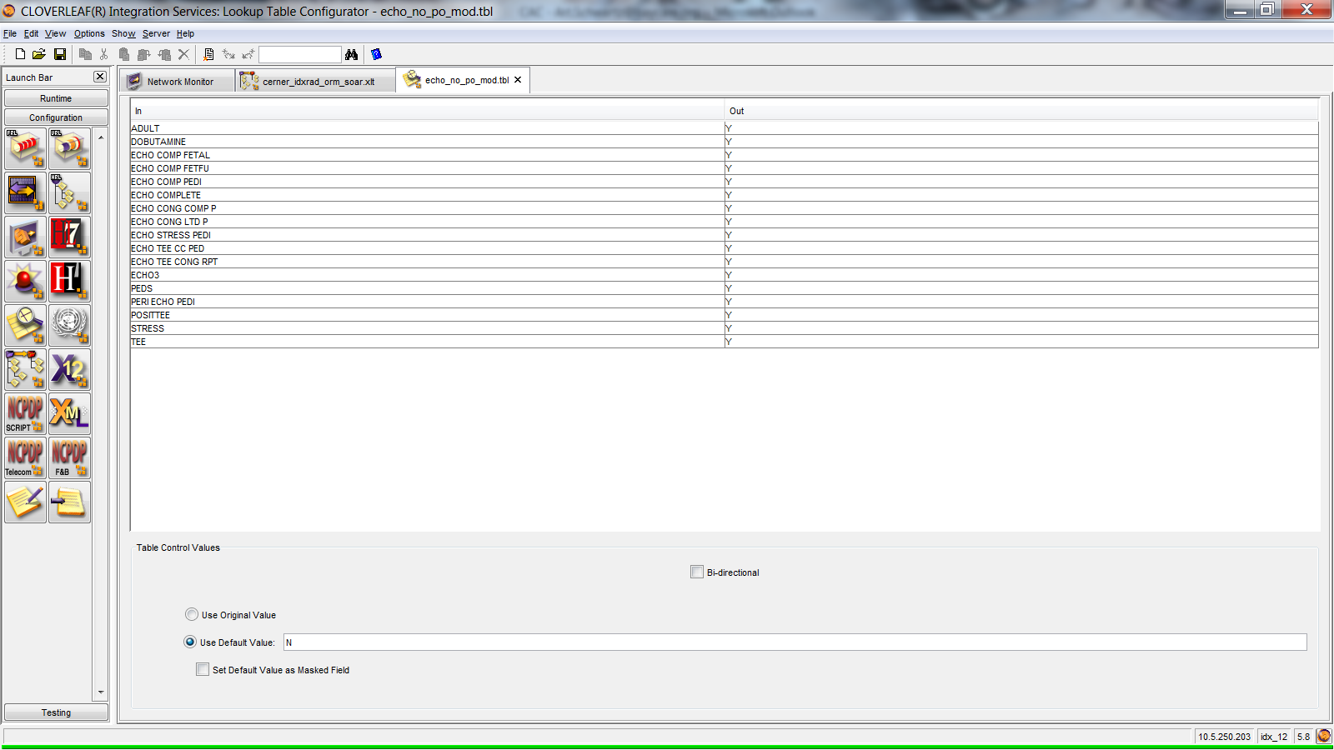

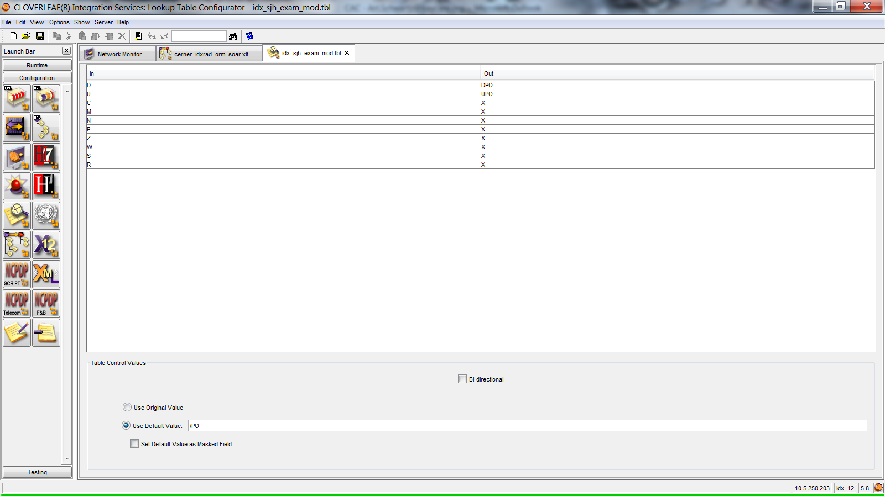

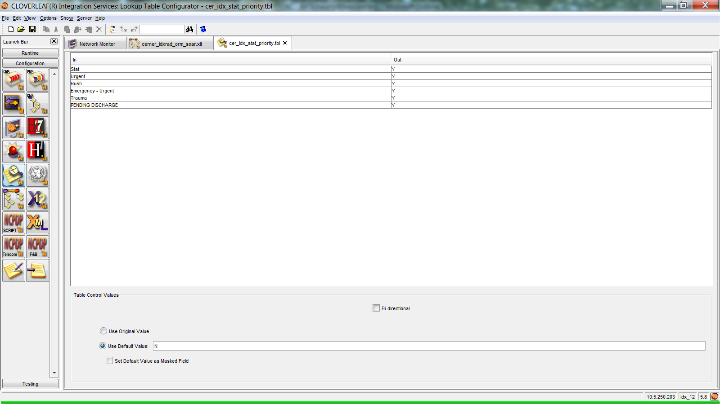

* End of document